- What is Github Action?
GitHub Actions is a CI/CD automation tool offered by GitHub company that automatically builds, tests, and deploys your application or infrastructure whenever a specific event occurs in your GitHub repository.
It’s a workflow automation service by GitHub. It automates all kind of repository related process and actions:
- Code Deployment (CI/CD Pipeline) – Automate code testing, building, and deployment.
- Code and Repository Management – Automatic code review, issue management etc.

Ex: Suppose you write code and upload it to GitHub. Normally, you might manually test the code and deploy it. GitHub Actions can automate these steps.
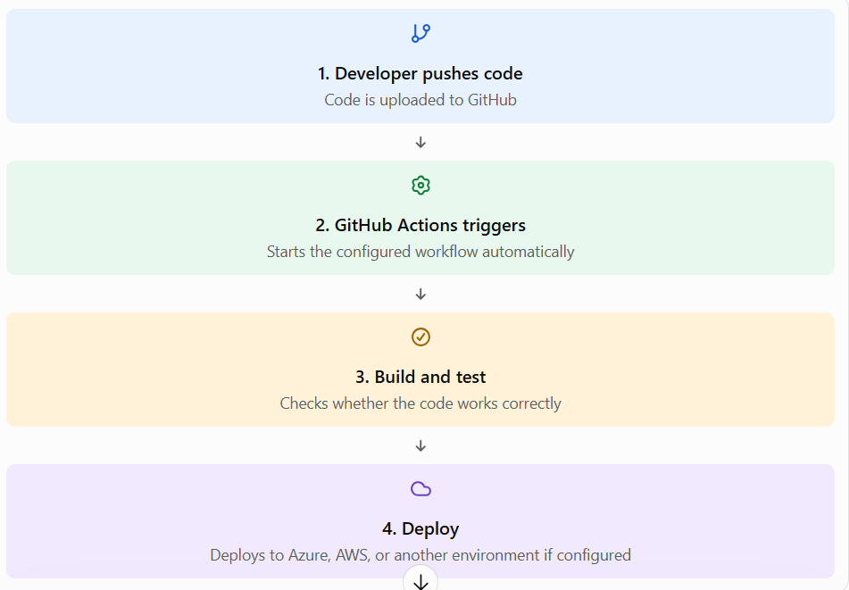
- GitHub Action Terminology:
- Workflow -The complete automation process.
- Event – What triggers the workflow, such as a code push
- Job – A group of steps that run on a machine
- Step – An individual task within a job.
- Action – A reusable component that performs a specific task
- Runner – The machine that executes the workflow.
- YAML – The file format used to define workflows.
- A workflow is usually stored in our repository under - .github/workflows/
- GitHub Vs Jenkins
GitHub Actions | Jenkins
Integrated into GitHub | Separate CI/CD automation server
Easy to start with GitHub repository | Often requires more server and plugin management
Supports hosted and self-hosted runners | Commonly uses configured agents
Workflows defined in YAML | Pipelines commonly defined in Jenkins file
- What is Repository?
A repository (repo) in GitHub is a place where you store and manage your project files, code, configuration files, and their change history.
Think of it like a project folder in your laptop, but stored on GitHub and accessible to your team.
- How does it work with GitHub Action?
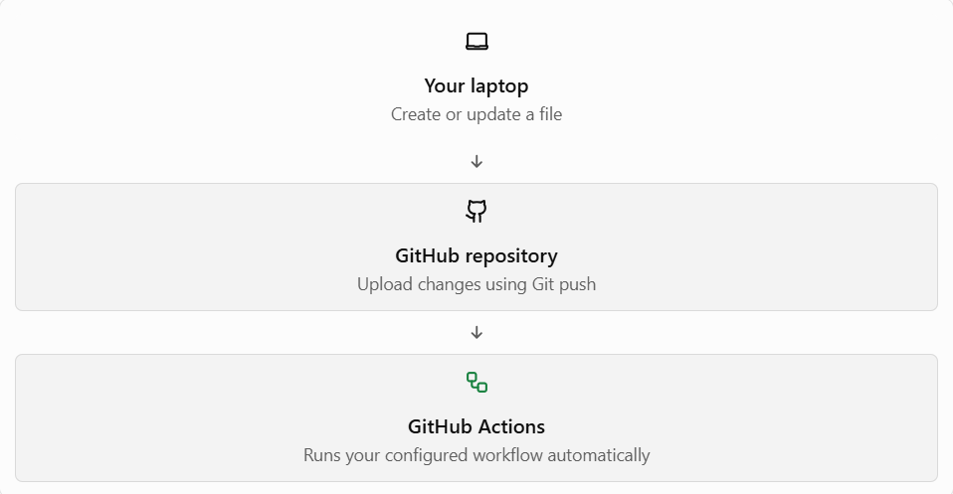
For example, when you push a change to your repository, GitHub Actions can automatically run your Terraform validation or application tests.
Terms:
- Git – Tracks changes to our files
- GitHub – An online platform where we host repositories.
- Repository - The project space containing your files and their history.
Note: A repository can be public (anyone can view it) or private (access is restricted to authorized people).
- What is CI/CD?
CI/CD stands for Continuous Integration and Continuous Delivery/Deployment.
- CI (Continuous Integration) – Automatically checks and test code whenever developers make changes.
- CD (Continuous Delivery) – Automatically prepares and validates code so it is ready for deployment usually requiring approval before production.
- CD (Continuous Deployment) – Automatically release changes to production after all required checks pass, without manual deployment approval.
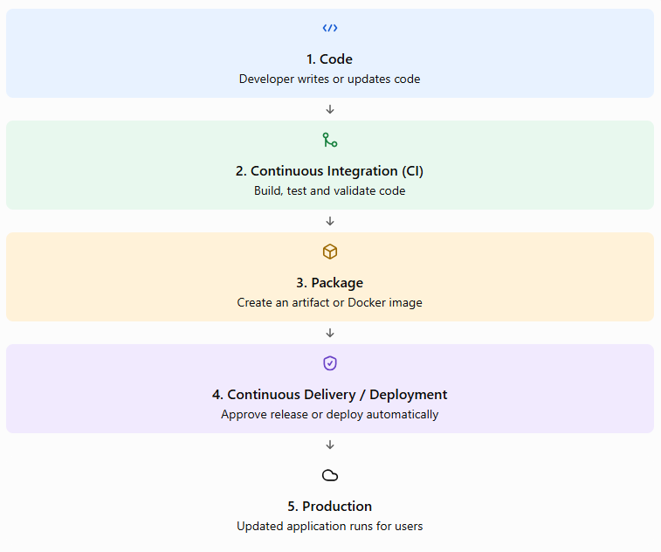
This automated sequence is called a CI/CD pipeline.
- GitHub Action fit in:
- GitHub stores your repository and code.
- GitHub actions run your automation workflows
- CI/CD is the process or practice of building, testing, and releasing software.
- What is Git, GitHub, & GitHub Actions?
- Git is a version control system tool that tracks changes in our files and allows you to see previous versions, compare changes, and work with branches.
- GitHub is a cloud-based platform for hosting Git repositories, managing source code, tracking changes, and enabling collaborative development among team members.
- GitHub Action runs automated workflows when events occur in your repository, such as a code push or pull request.
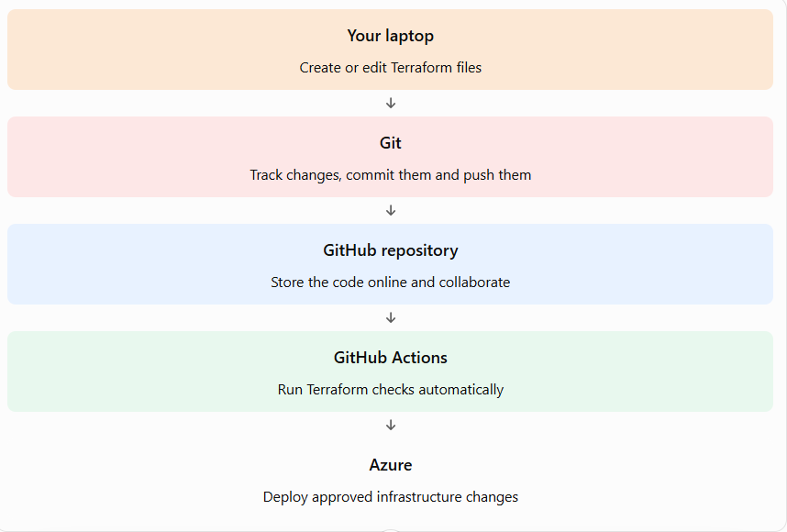
- What is IDE: Its stands for Integrated Development Environment. An IDE is a software application that combines the basic tools developers need to write, test, and debug code into a single program.
Ex: VS Code, Pycharm, Eclipse
- Git Repository – It is just a folder used by Git to track all changes of a given projects. To create a git repository simply run git init command inside the folder.
- .Git - .Git folder is created by default after initializing the folder into git repo to store all the relevant metadata of Git.
- Git Working Directory: This is where you work with files on your computer. For example, you create a file called main.py or modify your GitHub Actions workflow file, deploy.yml. At this point, the changes exist on your computer but haven't been staged or committed.
Command: git status
- Staging Area: Staging means selecting the changes you want to include in your next commit.
Command: git add <deploy.yml>
To stage all changes in the current repository:
Command: git add .
- Commit: A commit saves a snapshot of the staged changes in your local Git repository.
Command: git commit -m "Add main Python file"
- Git Push: Push uploads your local commits to a remote repository, such as GitHub
Command: git push origin main
git checkout <branch name>
git log
git checkout <commit id>
- Git Revert: git revert is used to undo the changes introduced by a previous commit without deleting the existing Git history. It's especially useful when you've pushed a commit to GitHub and want to undo it safely.
Command: git revert <commit-id>
Important: If reverting a commit causes conflicts, resolve the conflicts, stage the resolved files with git add, and continue with:
Command: git revert –continue
To cancel an in-progress revert:
Command: git revert –abort
- Git Reset: git reset is used to move the current branch back to an earlier commit and, depending on the option you choose, remove changes from the staging area or working directory. Unlike git revert, git reset can rewrite Git history, so be careful when using it on commits already pushed to a shared GitHub repository
- Git Branch: In Git, branches allow you to work on different features or fixes independently without directly affecting the main codebase. Imagine your project has a main branch containing stable code. You want to add a new feature, so you create a separate branch called feature-login.
Commands: # List local branches -> git branch
# List local and remote branches -> git branch -a
# To create a new branch -> git branch <branch name>
# Switch branch -> git switch <branch name>
# Create and switch in one cmd -> git switch -c <branch name>
# Rename branch -> git branch -m <new-branch-name>
# Delete a branch that has been merged -> git branch -d <branch name>
# Force delete a local branch -> git branch -D feature-login
# Create and checkout -> git checkout -b <branch name>
# Merge branch -> git merge <branch name>
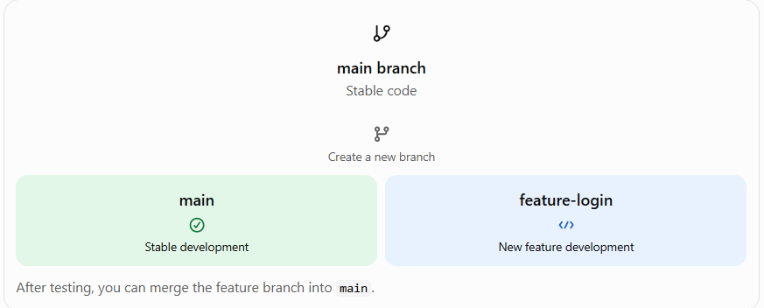

- Git Vs Github: Git tracks changes in your code on your computer. You can create commits, work with branches, merge changes, and revert mistakes.
Examples: git add, git commit, git branch, git merge.
GitHub stores Git repositories online and lets teams collaborate using pull requests, code reviews, issues, and GitHub Actions for CI/CD.
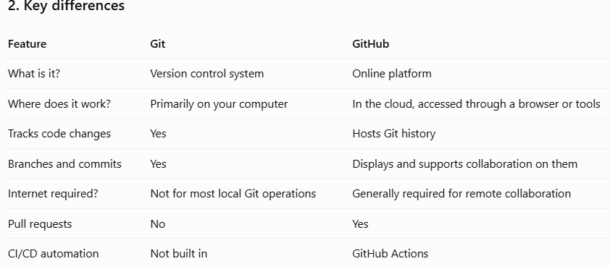
- Add git hub: Git remote add origin <Github repo url>
- Git push origin main: When I run this command for the first time to link my local repo with Github this will create a main branch in this remote repo, and push my commits of my local main branch to that remote main branch.
- Add user for authentication to push the code from local to github:
git remote set-url origin <repo-url>
For password need to generate the token at the below path:
Profile icon -> setting -> Developer settings -> Personal access token -> generate new token
- To push on github if we have multiple branches then we have to use that particular branch name in the command while pushing to github
git push origin <branch name>
- Git Pull: This command is used to download the latest code from the GitHub to local repository.
- Note: We can make our public repo to private from the setting tab.
- To get the remote repo URL run this command: git remote get-url origin
Note: Create a folder using powershell:
New-Item -Path "C:\Users\YourName\Desktop\MyFolder" -ItemType Directory
In the current location:
cd C:\Users\YourName\Desktop
mkdir MyFolder

- GitHub Action:
GitHub Actions is a CI/CD automation platform built into GitHub. It allows you to automatically build, test, and deploy your code whenever an event occurs in your repository, such as a code push or pull request.
- What GitHub do?
Imagine you're working on a cloud infrastructure project. Every time you push Terraform code to GitHub, you want to validate it automatically instead of running checks manually.
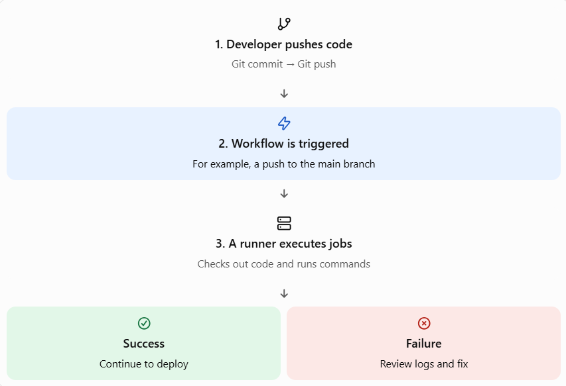
- Six core fundamentals:
  - Workflow: The complete automation process, defined in a YAML file under. github/workflows/.
  - Event: Defines what triggers the workflow.
  - Job: A group of steps that run on a runner. Jobs can run in parallel or depend on other jobs.
  - Step: An individual action or shell command inside a job.
  - Runner: The machine that executes the workflow's jobs.
  - Action: A reusable component that performs a task within a workflow.
